Finals Process Flow

Day 0 to Day 80
 | Contractor requests final inspection.
 | Project Manager / Project Leader do final inspection
 | a. | If work is completed satisfactorily, the Project Leader can enter the Time Charges Stopped date & the Work Completed date. This will enter the Substantially Complete date in Project Tracking.
 | b. | If work is not completed, Project Leader creates punch list items yet to be completed. Time Charges Stopped date can be entered at this time if the work on the punch list is not major. This will enter the Substantially Complete date in Project Tracking.
 | c. | If work is not completed & it is a major amount of work, then Contractor will continue working until work is done. Time can be extended by the Project Leader.
 | Project Leader enters the Time Charges Stopped date in FieldManager. This is filled in automatically in Project Tracking & it also automatically enters the Substantially Complete date.
 | a. | An automatic email is sent from Project Tracking to project staff (Contractor, Project Leader, Project Manager, Contract Specialist, Labor Compliance, Materials) to notify that the project is substantially complete.
 | b. | Contract Specialist: Print out 2 copies: one for finals box & one for central files. Save pdf of it in the share drive location for that project.
 | c. | The Contractor completes punch list work & finals documentation.
 |  | 1) | When done, the Project Leader reviews the punch list work to be sure it is complete.
 |  | 2) | When work is considered done by the Project Leader, the Punch List Completed date is entered in FIT and the All Work Completed date is entered in FieldManager (if no plant establishment or paint proving period). The Project Leader merges / sends the FIT data.
 |  | 3) | Project Leader notifies Contract Specialist to send Conditional Final Acceptance letter.
 |  | 4) | Contract Specialist sends Conditional Final Acceptance letter & enters date in Project Tracking.
 | Project Leader prepares project & material records for review
 | Labor Compliance reviews payroll records.
 | a. | When payrolls are cleared, Labor Compliance enters Payroll Clear Date in Project Tracking.
 | b. | Labor Compliance notifies Contract Specialist that payrolls have been cleared.
 | c. | Contract Specialist prints 2 copies of payroll clearance notification (one for finals box & one for central files). Save pdf of it in the share drive location for that project.

Day 81 to Day 110
1. | Project Leader delivers finals records to Contract Specialist.
2. | Contract Specialist receives finals records.
 | a. | Contract Specialist records Contract Records Submitted date in Project Tracking.
 |  | 1) | NW Region (Eau Claire): Contract Specialist enters number of boxes in the Madison Box # field.
 |  | 2) | NW Region (Eau Claire): Contract Specialists enters where records are located in the Records Location field in Project Tracking. This field will get updated as the records are moved to the Reviewer, Project Leader, etc. during the review process by the Contract Specialist.
 | b. | Contract Specialist gives materials records to Materials section for review.
 | c. | Contract Specialist contacts Project Manager to make arrangements for finals review.
 | d. | Once a reviewer is established for the finals review, Contract Specialist gives finals records to Records Reviewer & enters Contract Records to Reviewer date in Project Tracking.
3. | Records Reviewer reviews finals records.
4. | Materials reviews the materials records.

Day 111 to Day 125
1. | Records Reviewer contacts Project Leader to resolve problems with finals records.
2. | Materials contacts Project Leader to resolve problems with materials records.
3. | Project Leader works out discrepancies with contractor & makes corrections to the materials records or finals records.
4. | Records Reviewer reviews corrections made. If complete, the Records Reviewer returns the finals records to the Contract Specialist.
 | a. | Contract Specialist enters Contract Records Issues Resolved date in Project Tracking.
 | b. | Contract Specialist enters Reviewed by field in Project Tracking.
5. | Materials reviews corrections made.
 | a. | If complete, Materials submits DT1310 to Project Manager for signature.
 | b. | When DT1310 is signed, Materials enters Certification of Materials date in Materials Tracking. This will transfer over to the Project Tracking Status screen.
 | c. | Materials notifies Contract Specialist, Project Leader & Project Manager that materials have been certified.
6. | Contract Specialist makes 2 copies of Materials Certification – one for finals records & one for central files. A pdf is saved in the share drive location for that project.

Day 126 to Day 127
1. | Contractor requests final inspection.
2. | Project Manager / Project Leader do final inspection
 | a. | If work is completed satisfactorily, the Project Leader can enter the Time Charges Stopped date & the Work Completed date. This will enter the Substantially Complete date in Project Tracking.
 | b. | If work is not completed, Project Leader creates punch list items yet to be completed. Time Charges Stopped date can be entered at this time if the work on the punch list is not major. This will enter the Substantially Complete date in Project Tracking.
 | c. | If work is not completed & it is a major amount of work, then Contractor will continue working until work is done. Time can be extended by the Project Leader.
3. | Project Leader enters the Time Charges Stopped date in FieldManager. This is filled in automatically in Project Tracking & it also automatically enters the Substantially Complete date.
 | a. | An automatic email is sent from Project Tracking to project staff (Contractor, Project Leader, Project Manager, Contract Specialist, Labor Compliance, Materials) to notify that the project is substantially complete.
 | b. | Contract Specialist: Print out 2 copies: one for finals box & one for central files. Save pdf of it in the share drive location for that project.
 | c. | The Contractor completes punch list work & finals documentation.
 |  | 1) | When done, the Project Leader reviews the punch list work to be sure it is complete.
 |  | 2) | When work is considered done by the Project Leader, the Punch List Completed date is entered in FIT and the All Work Completed date is entered in FieldManager (if no plant establishment or paint proving period). The Project Leader merges / sends the FIT data.
 |  | 3) | Project Leader notifies Contract Specialist to send Conditional Final Acceptance letter.
 |  | 4) | Contract Specialist sends Conditional Final Acceptance letter & enters date in Project Tracking.
4. | Project Leader prepares project & material records for review
5. | Labor Compliance reviews payroll records.
 | a. | When payrolls are cleared, Labor Compliance enters Payroll Clear Date in Project Tracking.
 | b. | Labor Compliance notifies Contract Specialist that payrolls have been cleared.
 | c. | Contract Specialist prints 2 copies of payroll clearance notification (one for finals box & one for central files). Save pdf of it in the share drive location for that project.
6. | If there is a plant establishment or paint proving period, the process is on hold until the Project Leader can do a final inspection. Once the final inspection is done, the Project Leader will enter the All Contract Work Complete date & the process can continue on.
7. | If there is no plant establishment period:
 | a. | Contract Specialist reviews project to ensure the following:
 |  | 1) | Materials are certified.
 |  | 2) | Payrolls are cleared.
 |  | 3) | Finals reviewed & issues resolved.
 | b. | If everything is in order, Contract Specialist contacts Project Leader & Project Manager to send tentative final estimate.
 | c. | Project Leader sends tentative final estimate in FieldManager & notifies Project Manager & Contract Specialist.
 | d. | Project Manager approves tentative final estimate in FieldNet. The Semi-Final Estimate date gets automatically completed in Project Tracking.
 | e. | Contract Specialist does the following:
 |  | 1) | Prepares Tentative Final Estimate letter.
 |  |  | a) | Creates Tentative Final Voucher report from CAS. (See end of document for specific instructions on how to create).
 |  |  | b) | Print out & stamp the Tentative Final Voucher. (See end of document for sample stamps used by NW Region-Eau Claire office.
 |  |  | c) | Send Tentative Final letter & voucher to contractor. Email pdf of the letter & voucher to the Supervisor, Project Leader, Project Manager & Labor Compliance.
 |  |  | d) | The contractor needs to review & return a signed copy of the tentative final within 30 days. Create a task deadline in Outlook to follow-up on the contractor’s response.
 |  |  | e) | Complete the Tentative Final to Contractor date in Project Tracking.
 |  | 2) | Remove Team Evaluation of Contractor (DT2510) from finals records. If it is not in the finals records, then email a blank version to the Project Leader & Project manager to complete.
 |  |  | a) | Prepare DT2510 letter to send to contractor.
 |  |  | b) | Make 2 copies of the evaluation form.
 |  |  | c) | Save 1 copy in the finals records along with a copy of the DT2510 letter.
 |  |  | d) | Send 1 copy to central files along with a copy of the DT2510 letter.
 |  |  | e) | Send the original letter & DT2510 to contractor.
 |  |  | f) | Enter date it was completed in the Team Evaluation field in Project Tracking.
 |  | 3) | Print Subcontractor’s Final Payment & Retainage Certification (DT1340) form from the Project Tracking Warranty Forms Remarks tab on the Status screen.
 |  |  | a) | Prepare Subcontractor’s Final Payment & Retainage Certification letter.
 |  |  | b) | Send form to contractor with letter. They will need to sign & return with the signed tentative final before the final estimate can be sent.
 |  | 4) | Create Contractor’s Evaluation of Project Team (DT2509) form.
 |  |  | a) | Prepare DT2509 letter to send to contractor.
 |  |  | b) | Send form to contractor with the letter. They will need to sign & return with the signed tentative final.
 |  | 5) | Remove As-built plan (hard-copy & cd / dvd) from the finals records.
 |  |  | a) | Check the hard-copy as-built plan.
 |  |  |  | 1. | On the first page, check the as-built stamp fields to be sure they are correct.
 |  |  |  | 2. | List the number of contract mods & include a total value for all the contract mods.
 |  |  |  | 3. | Check that the Work Started & Work Completed dates are correct.
 |  |  |  | 4. | Check that the Final Contract Cost is correct. To do this, go to the Estimate screen in Project Tracking & use the total from the Item Total Earnings column.
 |  |  |  | 5. | Check that the Contract ID is correct.
 |  |  |  | 6. | If any changes are needed, cross out the original value & make the corrections in red. All changes to as-built plans need to be made in red.
 |  |  | b) | After that go through the hard-copy as-built plan & be sure that each page that has changes is marked with a post-it note. (I cut a stack of post-it notes into smaller pieces so that I don’t waste a tone of them doing this).
 |  |  | c) | When completed, initial & date on the front page.
 |  |  | d) | Open up the as-built plan on the cd / dvd.
 |  |  |  | 1. | Check that the as-built stamp fields are correct just as was done for the hard-copy version.
 |  |  |  | 2. | Make any necessary changes.
 |  |  |  | 3. | Save the corrected as-built plan to the cd / dvd if you can. If you cannot, create a new cd / dvd.
 |  |  |  | 4. | Also, save the corrected as-built plan to the project folder in the share drive under the Plans & Proposals folder.
 |  |  |  | 5. | Check that the Contract ID is correct.
 |  |  |  | 6. | Clip the cd / dvd version to the hard-copy as-built & send to central files.
 |  |  | e) | Contract Specialist enters the As-built Submitted date in Project Tracking on the As-built tab. Just enter it under the Plans heading. Enter a note in the Remarks field to show that the electronic as-built was also submitted.
 |  | 6) | Remove the Contractor Evaluations from the finals box.
 |  |  | a. | Create the Contractor Evaluation letter for each evaluation.
 |  |  | b. | Make 2 copies of the evaluations & 2 copies of the letter.
 |  |  | c. | Send originals to the contractors.
 |  |  | d. | Send 1 set of the copies to central files.
 |  |  | e. | Put the other set of the copies in the finals records.
 |  | 7) | Be sure finals records are boxed in the standard State Records Center boxes for finals storage.
 |  | 8) | Place finals records in holding area & wait for the signed documents to be returned from the contractor.

Day 128 to Day 157
1. | Contractor reviews Tentative Final estimate.
 | a. | If there are discrepancies, the Contractor contacts the Project Leader to resolve. There are 20 calendar days from the date for this to occur.
 | b. | If there are no discrepancies, the Contractor returns the signed Tentative Final estimate to the Contract Specialist.
2. | Contractor reviews the Contractor Evaluation of Project Team (DT2509), signs & returns with the Tentative Final estimate to the Contract Specialist.
3. | Contractor reviews the Subcontractor’s Final Payment & Retainage Certification (DT1340), signs & returns to the Contract Specialist.

Day 158 to Day 177
1. | If the Contract Specialist has not received any of the above documents within the 30 day time period from the contractor, the Contract Specialist should contact the contractor by email to follow-up on the status.
2. | Contractor & Project Leader work to resolve any issues or problems with the quantities.

Day 178 to Day 180
1. | Once issues have been resolved & the contractor has sent in the signed Tentative Final, Subcontractor’s Final Payment & Retainage Certification (DT1340) & the Contractor’s Evaluation of Project Team (DT2509), the Contract Specialist will:
 | a. | Enter the Semi-Final from Contractor date in Project Tracking.
 | b. | Enters the Subcontractor’s Final Pmt Cert date in Project Tracking.
 | c. | Enter the Contractor Eval of Team date in Project Tracking.
 | d. | Send email to Project Leader & Project Manager to see if the Final Acceptance letter can be sent.
2. | If Final Acceptance letter can be sent, the Contract Specialist prepares the letter & sends to the contractor.
 | a. | A pdf copy is sent by email to the Supervisor, Project Leader, Project Manager, Labor Compliance & Regional Maintenance staff.
 | b. | A cc is sent to the County Commissioner (hard-copy).
 | c. | The Final Acceptance date gets entered in Project Tracking. This should be the date the Project Leader & Project Manager tell the Contract Specialist to send the letter.
 | d. | The Final Acceptance to Contract date gets entered in Project Tracking. This should be the date the Contract Specialist actually sends the letter. This can be the same as the Final Acceptance date.
3. | Once the Final Acceptance letter is sent, the Project Leaders sends the Final Estimate from FieldManager. This will automatically fill in the Final Estimate Created date in Project Tracking.
4. | The Project Manager approves the Final Estimate in FieldNet. This will automatically fill in the Final Estimate Approved date in Project Tracking.
5. | The Project Leader will send a signed copy of the Final Estimate to the Contract Specialist.
6. | Contract Specialist files the Final Estimate copy in the finals records.
7. | The Contract Specialist will follow-up in a few days after the Final Estimate was approve & check the EAPS screen to be sure that the final payment was made.
8. | The Contract Specialist will also check to see if there are other open encumberances for that project id. If there are, then the Contract Specialist will contact the Project Manager to see if they can be closed.
9. | Once the Final Estimate is paid, the Contract Specialist will send the Completion Certificate.
 | a. | In Project Tracking Status screen, go to the Warranty Forms Remarks tab.
 | b. | At the bottom of the screen, click the Print Completion Certificate button.
 | c. | Make 2 copies of the signed Completion Certificate.
 | d. | Send 1 copy to the central files.
 | e. | Send the original to the bonding company listed at the top of the certificate.
 | f. | Send 1 copy to the finals records.
 | g. | Scan & save a copy to the project share drive location.
 | h. | Send a scanned copy to FHWA by email
 | i. | Enter the Completion Certificate date in Project Tracking.

After Final Payment
1. | The Contract Specialist sends the finals records to storage or to the Records Manager.
2. | The Contract Specialist enters the Records to Storage date in Project Tracking.

Print Tentative Final Estimate From CAS
  - Log into CAS.

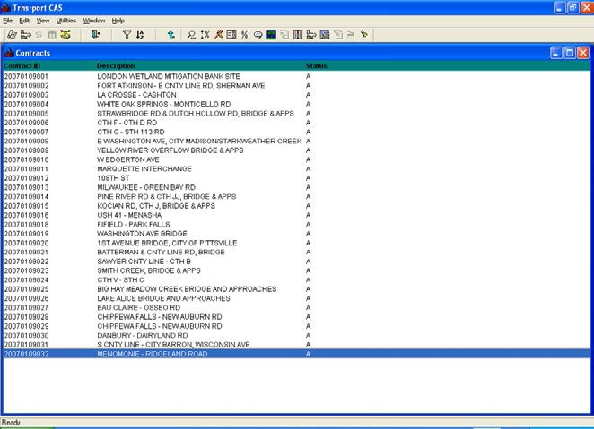
Projects icon
2. Choose the contract you want.

- Click the Projects icon at the top of the screen (5th one from right).

- Click the Vouchers icon at the top of the screen (2nd one from right).
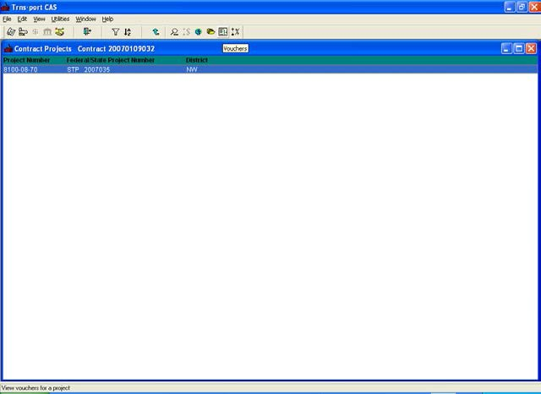
Vouchers Icon

- Highlight the voucher you want to print and right-click on it. Choose the Run Process option.

- Choose Generate Partial Payment Vouchers. Click Ok.

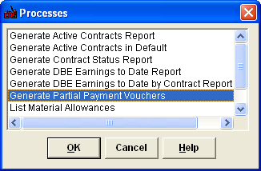
- Click submit.

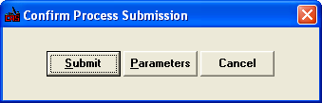
- Click Ok.

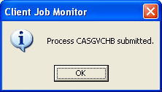
- Go to the File Menu. Choose Process Status.

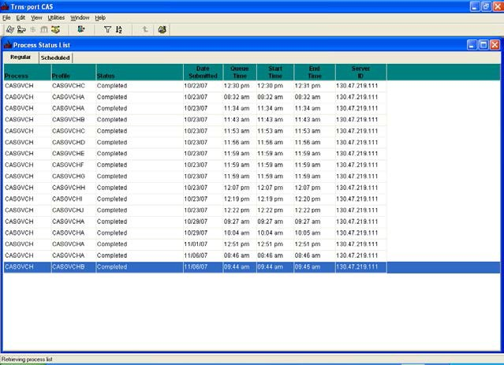

- Highlight and double-click the voucher you ran.

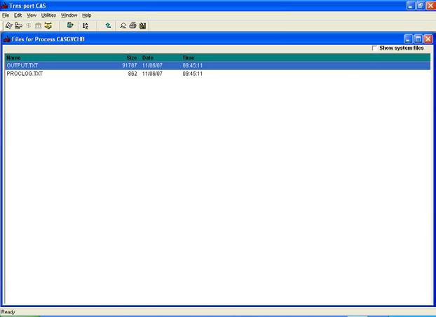
- Double-click the Output.txt file.

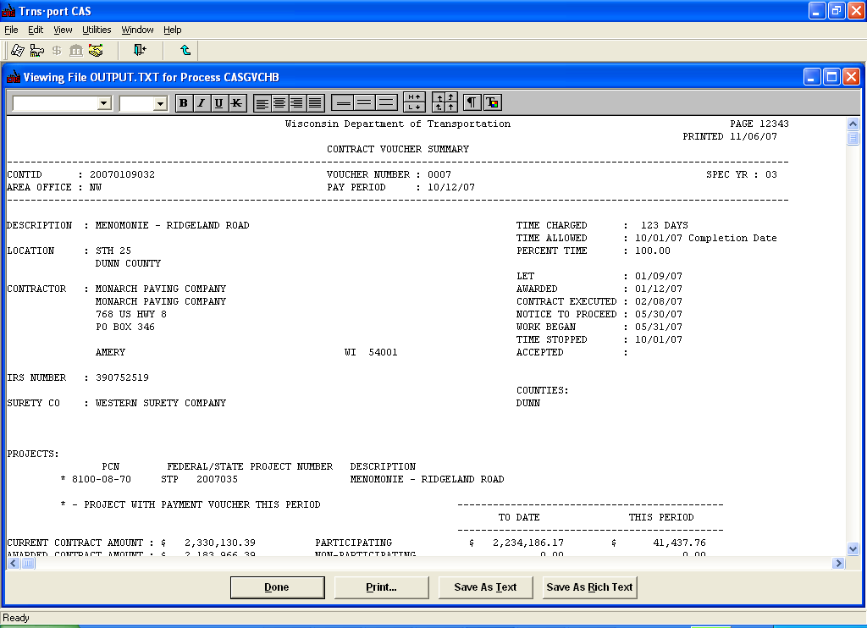
- Click the Print button.

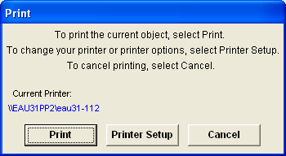

- Choose the Printer Setup button.

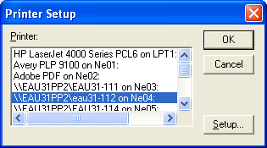
- Click the Setup button.

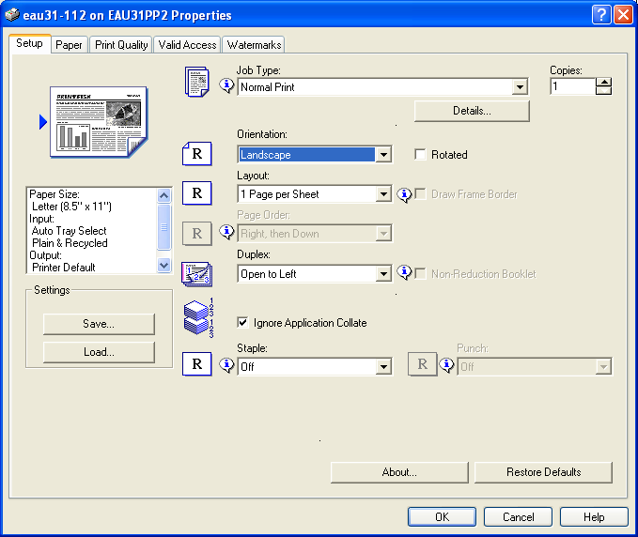

- Change your printers settings so that the orientation is Landscape rather than Portrait. Click the Ok button.

Tentative Final Stamps

FINAL QUANTITIES

PLEASE SIGN AND RETURN WITHIN 30 DAYS TO:

Jennifer Oldenburg Contract Specialist
Wisconsin Department of Transportation Northwest Region
718 West Clairemont Avenue Eau Claire WI 54701

If a signed copy is not received within 30 days a final estimate will be processed.

Accepted for Contractor by:
Name: ____________________________________________

Title:______________________________________________

Date: _____________________________________________

Project Tracking Screens
- Status Screen – Dates Tab
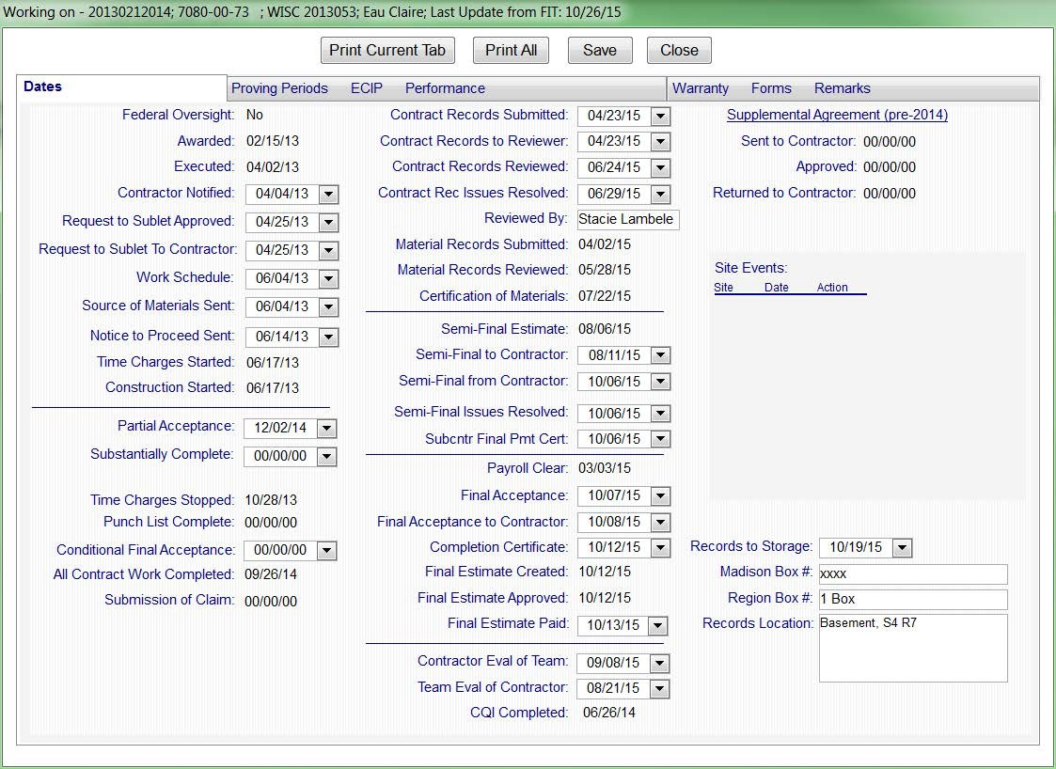

Time Charges Stopped Date: Entered by PL in FieldManager when punch list items are complete.
  - Punch List Complete: Entered by PL in FieldManager when punch list items are complete.
  - Conditional Final Acceptance: Entered by CS in Project Tracking when conditional final acceptance letter is sent.
  - All Contract Work Completed: Entered by PL in FieldManager when all contract work has been completed, including plant establishment & paint proving periods completed.
  - Contract Records Submitted: Entered by CS when final records are received.
  - Contract Records to Reviewer: Entered by CS when final records are given to the Records Reviewer.
  - Contract Records Reviewed: Entered by CS. This is the date the RR reviewed the records.
  - Contract Re Issues Resolved: Entered by CS. This is usually the date that CS receives the records back after all discrepancies & corrections have been made.
  - Reviewed By: Entered by CS. Name of person who was Records Reviewer.
  - Certification of Materials: Entered by Materials in Materials Tracking once the materials have been certified.
  - Semi-Final Estimate: Entered by PL in FieldManager. This is the date that the tentative final was sent.
  - Semi-Final to Contractor: Entered by CS. This is the date the CS sends the tentative final paperwork.
  - Semi-Final from Contractor: Entered by CS. This is the date the CS received the signed tentative final paperwork back from the Contractor.
  - Semi-Final Issues Resolved: Entered by CS. This is the date any issues found by the Contractor in the tentative final are resolved with the department.
  - Subcntr Final Pmt Cert: Entered by CS. This is the date the Subcontractor Final Payment & Retainage Certification was received.

  - Payroll Clear: Entered by Labor Compliance when payroll reviews are completed & considered cleared.
  - Final Acceptance: Entered by CS. This is the date that the PM & PL give final acceptance for the project.
  - Final Acceptance to Contractor: Entered by CS. This is the date the CS sends the final acceptance letter.
  - Completion Certificate: Entered by CS. This is the date the Completion Certificate was sent by the CS.
  - Final Estimate Created: Entered by PL in FieldManager. This is the date the Final Estimate was sent by the PL.
  - Final Estimate Approved: Entered automatically when the PM approves the Final Estimate in FieldNet.
  - Final Estimate Paid: Entered by CS. This is the date that EAPS shows when the final payment has been made.
  - Contractor Eval of Project Team: Entered by CS. Date DT2510 was received.
  - Team Eval of Project Team: Entered by CS. Date DT209 was done.
  - CQI Completed: Automatically entered when CS enters CQI evaluation which is done approximately 6 months after all work has been completed.
  - Records to Storage: Entered by CS when finals records are submitted to records management for storage.
AA. Madison Box Number: Entered by CS. NW Region uses it to indicate how many boxes are included in the finals records submittal.
BB. Region Box Number: Entered by CS. NW Region uses this field to enter the future date when the records will be destroyed.
CC. Records Location: Entered by CS. Place where the finals records will be kept.

- Status Screen – Warranty Forms Remarks tab.

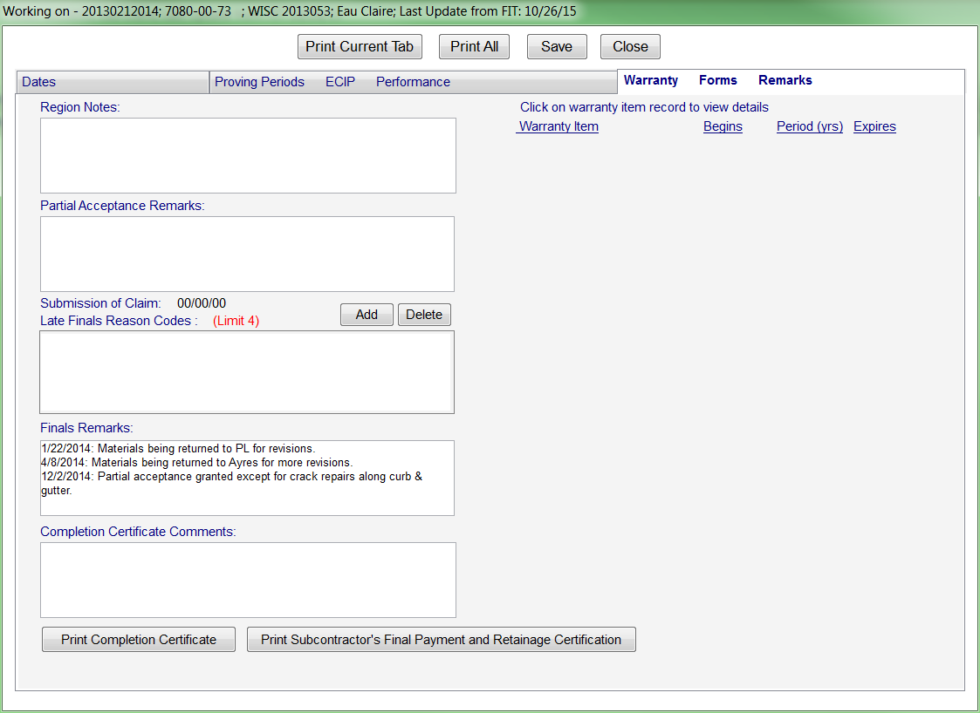
  - Region Notes: Not used.
  - Partial Acceptance Remarks: Not used.

Submission of Claim: Entered by PL in FIT.
- Late Finals Reason Codes: Entered by CS only when a project is late in getting finals completed.
- Finals Remarks: Entered by CS to make notifications on the status of finals.
F. Completion Certificate Remarks: Not used.

Print Completion Certificate: Used by CS to print Completion Certificate.
- Print Subcontractor’s Final Payment & Retainage Certification: Used by CS to print Subcontractor’s Final Payment & Retainage Certification.

- As-Built Screen

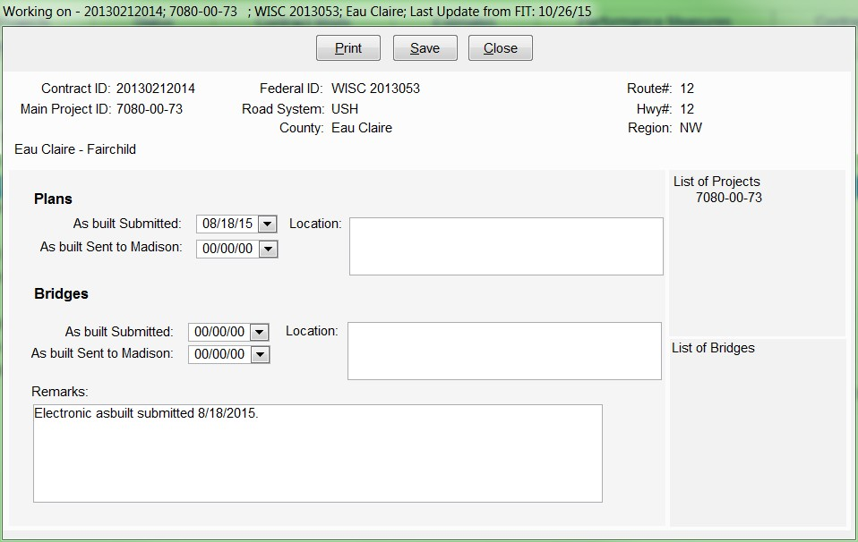
Only fields used:

Plans – As built Submitted: Entered by CS when hard-copy as-built submitted to Records Manager.
  - Remarks: Entered by CS to note when the electronic asbuilt was submitted to Records Manager.

Additional References
Finals Process for Let Project Closeout, Project Administration Tools, February 9, 2015: http://wisconsindot.gov/rdwy/admin/finals.pdf

Finals Process

CPROCESS FLOW DIAGRAM

PM/PL:
Inspection/Site
PM:
Work complete?

PL: Create
NO Punch-List;
provide to

PM:
Substantially

NO Continue work

Finals Process for Let Project Closeout
CTR: Request Inspection
Walk Through

YES
(no punch-
list)
Contractor
Complete?
YES
or Extend Time

Day 0 - process

CTR: Receives Subst. Complete notice; Completes Punch-List work and documentation
PL: Stop Time in FieldMgr

No punch-list

Automatic notice sent
CS: Receive Subst. Complete notice
ME: Receive Subst. Complete notice
ERO: Receive Subst. Complete notice;
Notify
start

15 business days / 21 calendar days

Contractor;

PL: Review punch-list work/docs

PL: Restart Time

PM:
Punch-List complete? YES
NO

CS: Cond. Final Acceptance letter to contractor /enter date in Project Tracking

PL: Enter “Punch-List Complete” date in FIT

PL: Enter “All Contract Work Complete” date in FieldMgr (skip and go to records prep if plant establishment)

PL: Prepare material and contract item records for review
Review records;
Enter Payroll Clear Date into Project Tracking;
Notify Contract Specialist of Payroll Clear Date
Day 21

60 calendar days

PL: Deliver records to Contract Specialist

CS: Confirm receipt of records / enter date in Project Tracking

CS: Distribute materials records to Materials Engineer

CS: Distribute contract records to Records Reviewer / enter date in Project Tracking

RR:
Contract Records review process

ME: Enter “materials records submitted” date in MTS; complete materials certification process
Day 81

30 calendar days

RR: Communicate problems/issues to Project Leader / submit DT2076 form to Contract Specialist

ME: Communicate problems/issues to Project Leader / submit DT1310 form to Project Manager
Day 111

PL: Work with Contractor to resolve materials cert or contract item records problems/issues

CTR: Work with Project Leader to resolve materials cert or contract item records problems/issues
15 calendar days

IF Plant Establishment, Process Time on hold

PL: At end of plant establishment period, inspect planting; Enter “All Contract Work Complete” if inspection passed

PM:
Criteria for Semi-Final Est. met?
NO

YES

PL: Create Semi-Final Estimate and notify Contract Specialist

CS: Send Semi-Final Estimate to Contractor / enter date in Project Tracking
Day 126

2 calendar days
* 14 days from All Contract Work Complete for Plant Establishment

Day 128

CTR: Review Semi-Final Estimate and return to department *Day 140
30 calendar days

PL: Resolve Semi-Final Estimate problems/issues CTR: Resolve Semi-Final Estimate problems/issues
Day 158
*Day 170
20 calendar days
Day 178
*Day 190

PM: Resolve
issues
PM:
Criteria for Final
Acceptance met?
NO
YES
CS: Send Final
Acceptance to Contractor/enter date in Project Tracking
PL: Create
Final Estimate in FieldMgr
PM: Approve
Final Estimate
CS: Prepare/distribute
completion certificate / enter date in Project Tracking
Day 180 - process
2 calendar days
end
Project Manager (PM)
Contract Specialist (CS)
Materials Engineer (ME)
Contractor (CTR)
Project Leader (PL)
Equal Rights Officer (ERO)
Records Reviewer (RR)
*Day 192 for projects
with plant establishment

February 9, 2015 Page 1

