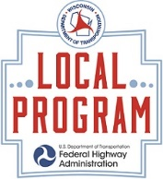
Local Program
WEEKLY CONSTRUCTION UPDATE
Please return this form to the Sponsor, WisDOT Project Manager, & WisDOT Supervisor, and NE Region Communication Specialist, Mark Kantola (mark.kantola@dot.wi.gov) no later than noon on Thursday updating work activities for the current week and upcoming week for each of your NE Region Local Program project(s).
Dates Covered (example: April 2 – April 13):
Project ID (example: 3271-00-71):
Project Name (example: Oak Street Bridge):
Schedule:
Project Cost:
Location/terminals (including city and/or county(s), ramps, etc):
Description of overall work (be specific):
This week’s work (be specific):
Next week’s work (be specific):
Traffic impacts (include detour map as separate attachment):
Special information of interest needed by the public concerning this project:

Name of person providing Weekly Construction updates AND photographs of project bi-monthly once the project begins (including e-mail address and phone #)
Name:
E-mail:
Phone #:

