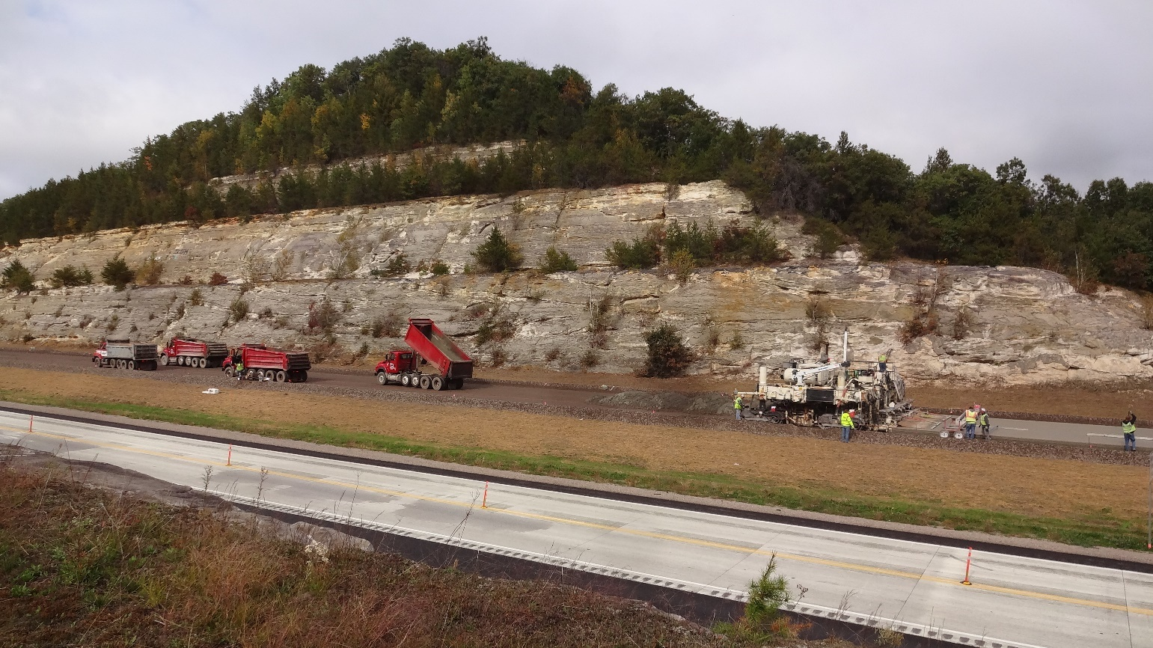



**INSPECTION GUIDELINES**

**FOR** **NW REGION CONSTRUCTION**

**2018**

Table of Contents

REMOVALS 2

TRAFFIC CONTROL 3

CONTRACTOR STAKING 8

EARTHWORK 9

BASE AGGREGATE 11

PIPE CULVERT 12

STORM SEWER 13

CONCRETE PAVEMENT 14

ASPHALT PAVEMENT 16

CONCRETE BRIDGES AND CONCRETE MASONRY 17

STEEL BRIDGES 19

PILING 20

STRUCTURES (GENERAL) 21

ANCILLARY STRUCTURES 22

BOX CULVERTS, RETAINING WALLS, AND ENDWALLS 23

ANCILLARY CONCRETE 24

PAVEMENT MARKING 25

LANDSCAPING 26

ELECTRICAL 27

MATERIALS 28

INCIDENTAL CONSTRUCTION 29

The purpose of this document is to be used by construction staff as a resource prior to inspection of upcoming work. Comments, corrections, and updates are encouraged. Please forward them to Jenny Fesenmaier at [jennifer.postlewaitefesenmaier@dot.wi.gov](mailto:jennifer.postlewaitefesenmaier@dot.wi.gov)

Topics being developed: Milling and Chip Seals, CIR, Epoxy Bridge overlay

REMOVALS

* CMM reference: 3-15 <http://roadwaystandards.dot.wi.gov/standards/cmm/cm-03-15.pdf>
* Standard Specifications reference: Sections 203 and 204 (also see bid item) <http://roadwaystandards.dot.wi.gov/standards/stndspec/ss-02-03.pdf> <http://roadwaystandards.dot.wi.gov/standards/stndspec/ss-02-04.pdf>
* See Special Provisions for additional requirements.
* Clearly mark removal limits and contact adjacent property owner and contractor (discretion)
  + Measure removals according to standard specifications for that bid item and to the accuracy indicated in the CMM 2-32.5 <http://roadwaystandards.dot.wi.gov/standards/cmm/cm-02-32.pdf>
  + Use Pantry documents to aid measurement and keep originals.
  + Indicate “measured by” date and “computed by” date.
  + Have computations checked – indicate “checked by” date.
* Photograph or video existing conditions with removal limits shown.
  + Document “tie-in” locations.

- Verify that the plan elevations for the tie in locations match the existing.

* + Document standing water after rain events.
* Assure environmental regulations are adhered to, especially in the removing of buildings and abandoning of wells.
* Document method of removal, removal dates, weather conditions, labor and equipment hours.
* Verify disposal locations are in accordance with the Erosion Control Implementation Plan (ECIP).
* Meet with Area Maintenance Coordinator (or local maintaining authority) to investigate any existing problems such as flooding/drainage issues, frost heaves, etc… that may not have been addressed in the plan.

NOTES:  
Local Road Identification Signs are the responsibility of the local unit of government (both removal and reinstallation)  
Contact local unit(s) of government prior to construction to let them know that removal is their responsibility, invite them to weekly meetings when appropriate, and provide anticipated starting/completion dates and project limits  
Temporary signs for EMS during construction are also their responsibility  
Mailboxes – See CMM 3-15.5 – contractor should notify owners and postmaster – Project Engineer should confirm with postmaster notice has been provided and see if they are willing to provide the mailbox installation guide. <http://roadwaystandards.dot.wi.gov/standards/cmm/cm-03-15.pdf>



TRAFFIC CONTROL

* CMM reference 1-45 <http://roadwaystandards.dot.wi.gov/standards/cmm/cm-01-45.pdf>
* Standard Specifications reference: Section 643 (also see bid item) <http://roadwaystandards.dot.wi.gov/standards/stndspec/ss-06-43.pdf>
* MUTCD reference: <http://mutcd.fhwa.dot.gov/pdfs/2009r1r2/pdf_index.htm>
* WI supplement to MUTCD: <http://www.dot.wisconsin.gov/business/engrserv/wmutcd.htm>
* Work Zone Safety: <http://epdfiles.engr.wisc.edu/pdf_web_files/tic/handbooks/WorkZoneSafety.pdf>
* Flaggers Handbook: <http://epdfiles.engr.wisc.edu/pdf_web_files/tic/handbooks/FlaggersHandbook.pdf>
* See Special Provisions for additional requirements.
* Review TMP (from design) for commitments. Be familiar with the document and have a copy at the field office.
* Project Engineer must enter Lane Closure System (LCS) information 7 calendar days prior to start of closures and any stage changes. <http://transportal.cee.wisc.edu/closures/>
* Project Engineer must make sure Emergency Contact List has a 24-hour traffic control contact posted and has been sent to all appropriate parties listed on the bottom of form.
* Inspect traffic control at initial set-up and stage changes prior to traffic control contractor leaving the project. Then perform daily inspections with some nighttime inspections. Use: TrafficControlInspectionChecklist.dotm found in the pantry statewide forms folder for documentation.
* If field changes are needed, reference the project plans and appropriate Standard Detail Drawings and/or contact the engineer. Conform to appropriate SDD’s when possible and reasonable.
* Quality Guidelines: Refer to pamphlet from ATSSA “Quality Guidelines for Temporary Traffic Control Devices.” Contact regional Traffic section for guidance.
* Document traffic control conditions observed daily and note discussions with contractor and report any shortfalls to engineer.
* Review and file weekly traffic control diaries from contractor and ensure at least one weekly night inspection has been performed. See section 643.3.2 of the Standard Specifications.

<http://roadwaystandards.dot.wi.gov/standards/stndspec/ss-06-43.pdf>

* If any crashes occur see CMM 1-55 <http://roadwaystandards.dot.wi.gov/standards/cmm/cm-01-55.pdf> If severe injuries or fatalities occur, additional information is needed, see above for reporting to the Bureau of Traffic Operations.
* Measure quantities and record date/time for every traffic switch, and at intervals directed by engineer. Use: TrafficControl.xlsx in the pantry statewide spreadsheets for documentation

**Work Zone Tips**

2018 NW Region Construction Conference

* **Signing** 
  + Temporary Sign Supports can be used for less than 7 days.
  + New Standard Detail 15D38 for Traffic Control Sign Mounting.
  + For speeds greater than 45 mph, 1000 feet is required between Road Work Ahead and Road Work 1000 Feet signs.
  + Yield Ahead and Yield signing at entrance ramps within a lane closure to have flags installed.
  + End Road Work signs required.
* **Flagging** 
  + Temporary Rumble Strips required if stationary over 2 hours. Follow manufacturers recommendations for strip spacing.

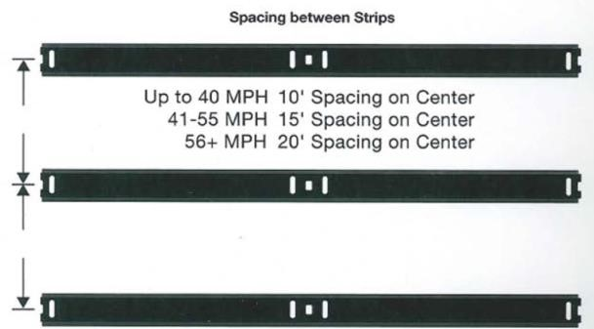

* + Layout according to detail and follow sign spacing guidance.
    - Maximum 3500 Feet between Flagger and Flagger Symbol sign.
    - Road Work Ahead sign is to be used, Road Construction Ahead is no longer used.

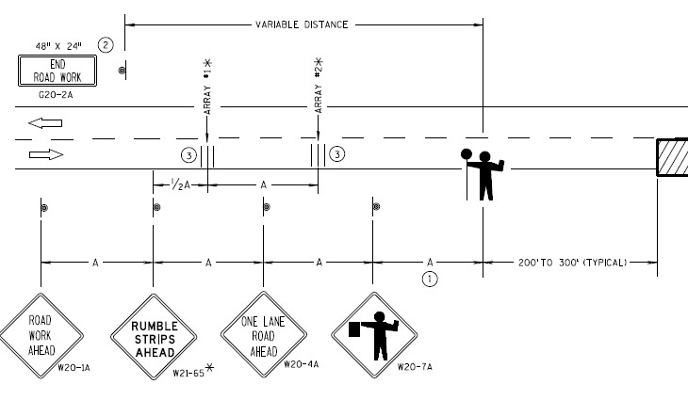

* + Flaggers are to be trained as described in the WMUTCD (standard spec 104.6.1(4)   
    ▪ No leaning on vehicles, sitting in chairs, etc. Need a clear exit path.

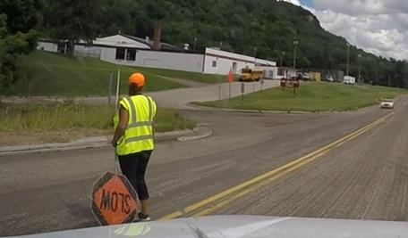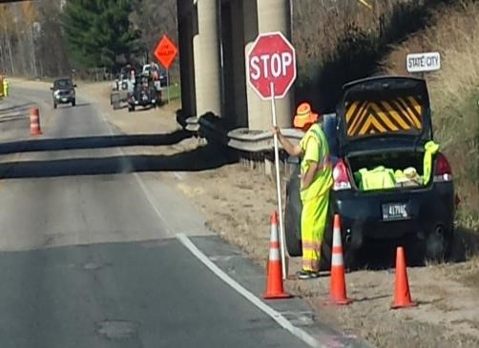

* **Drums** 
  + Have the contractor pull the drums back over the centerline into the closed lane whenever practical to increase lane width for traffic and reduce getting hit. o Sludge removal and cleaning drums is sawing contractor’s responsibility and is required to be done at the end of each day’s work. (standard spec 690.3.3(2)

* **Inspections** 
  + The Surveillance and Maintenance item going away. Emphasis with the 2018 spec rewrite is on the contractor to do after each setup and as often as necessary.
  + For additional information, see CMM Chapter 1-45.
    - Construction staff should be reviewing traffic control daily during the week and document using the Work Zone Traffic Control Inspection Checklist in Pantry.

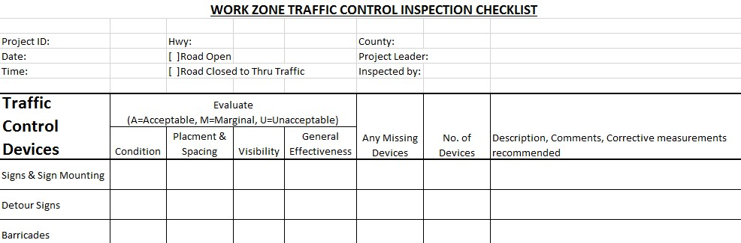

* + - Regional Work Zone Traffic Control Engineer may do a field review depending on resourcing and project complexity. Send project schedule after the pre-construction meeting to chad.hines@dot.wi.gov

* **Work Zone Crashes** 
  + Severe injury or Fatal crashes should be reported to Bureau of Traffic Operations at:

DOTWorkZoneCrashes@wisconsin.gov

* + Provide information such as project ID, location, crash type, time of day, if it was at the end of a queue and if it was due to the work zone set up. Document entire accident area, particularly work zone traffic control and any work operations with pictures

* **Lane Closure System Entries** 
  + 7 Calendar days for closures with restrictions. o 3 Business days for closures without restrictions.
  + Notify approver of entries.

* **Contact Information** o Questions or problems with traffic control in the field?
  + Contact: Chad Hines

chad.hines@dot.wi.gov

715-577-3698

EROSION CONTROL

* CMM reference: 6-45 <http://roadwaystandards.dot.wi.gov/standards/cmm/cm-06-45.pdf>
* Standard Specifications references: Section 107 (also see bid item) §107.20 <http://roadwaystandards.dot.wi.gov/standards/stndspec/ss-01-07.pdf> and <http://roadwaystandards.dot.wi.gov/standards/stndspec/ss-06-28.pdf>
* Trans 401 reference: <http://docs.legis.wisconsin.gov/code/admin_code/trans/401.pdf>
* Erosion Control Product Acceptability Lists (PAL) for Multi-Modal Applications: <http://wisconsindot.gov/Pages/doing-bus/eng-consultants/cnslt-rsrces/tools/pal/default.aspx>
* See Special Provisions for additional requirements.
* Review the approved ECIP prior to layout and confirm stockpile locations with contractor.
* If possible, review project during or immediately after a rain event to look for areas of higher water flow and adjust layout of BMP’s accordingly.
* Lay out erosion control items utilizing the plan and approved ECIP to FIT TO FIELD CONDITIONS.
* Do not allow ground disturbing activities prior to initial inspection of erosion control.
  + Verify all products are on the PAL.
  + Inspect and document erosion control weekly, after every rainfall event greater than ½”, and at the beginning of each construction stage as required by Trans 401. Use: ErosionControlDiaryInspectionFormWS1072.dotm from the pantry statewide forms \ WSForms.
  + Notify Project Engineer and DNR if any discharges occur into waterways or wetlands.
* If corrective action is needed, fill out the Erosion Control Order found in the pantry statewide forms \ WSForms ErosionControlOrderWS1074.dotm
  + Note: An erosion control mobilization is not to be paid for corrective action.
* Document the weather conditions, labor, equipment and hours on a daily basis.
* Measure and document appropriate bid items.
* Check erosion control measures prior to a Major Rain event, if you know it is coming.
* Maintain all erosion control related documents in the erosion control binder.  Have the binder available for review in the field office at all times.  See next page for binder contents.
* Transportation Construction General Permit – forms and instruction located <http://wisconsindot.gov/Pages/doing-bus/eng-consultants/cnslt-rsrces/environment/erosion-ctrl-drainage.aspx>

Erosion Control Binder Contents

* + Restart Orders* Front of Binder

Newest Items

* + Temporary Suspensions of Work Orders*
  + Copies of ECIP Amendments*
  + Copies of Erosion Control Orders
  + Copies of Required Inspections
  + Review and Comments of ECIP
  + Erosion Control Implementation Plan (ECIP)
  + Review and Comments on Erosion Control Plan
  + Copy of NOI
  + Review and Comments on Environmental Commitments

Back of Binder

Oldest Items

* + Copy of Trans 401

* if required

CONTRACTOR STAKING

* CMM reference: 7-00 <http://roadwaystandards.dot.wi.gov/standards/cmm/cm-07-00toc.pdf>
* Standard Specifications reference: Section 650 (also see bid item) <http://roadwaystandards.dot.wi.gov/standards/stndspec/ss-06-50.pdf>
* FDM Reference: 19-10-43 <http://roadwaystandards.dot.wi.gov/standards/fdm/19-10.pdf>
* See Special Provisions for additional requirements.
* Obtain contractor survey packet from design Project Engineer. See CMM 7.10.3 and FDM 19-10-43 for requirements.
* Make sure that if a field change has been made to the plans, that this information has been given to the surveyor prior to them coming to the project. If there are any addenda to the plans that affect staking, be sure the staking contractor has that information.
* Verify plan control is still in place and usable. If not, contact Regional Survey Coordinator.
* Check project for existing survey markers. Verify that they will not be disturbed. If they need to be relocated contact Regional Survey Coordinator.
* Note benchmarks set on fire hydrants, pole bases or telephone poles. Have they been moved / reconstructed if they will be eliminated due to the construction work?
* Randomly check survey stakes.
  + The frequency of checks is not defined; early in the project, daily verification is expected. Once confidence in the ability of the crews is obtained, less frequent checks are acceptable. Provide results to the contractor per Sec. 105.6.2(4) of the Standard Specifications.
* For Culvert staking, verify pipe inlets and outlet elevation match existing conditions and drainage, especially at channel locations.
* Obtain copies of survey books / notes daily and randomly check computations. Keep in project records.
* Document the weather conditions, labor and equipment hours on a daily basis.
* Measure and document appropriate bid items.
* Prior to final payment, Project Engineer should obtain a copy of the completed contractor survey packet and verify all information from the table in CMM 7.10.3 is included.
* Section corners are to be verified and tied off.
* Tie sheets are required before payment
* Approved method of replacement per the SDD’s or the Special Provisions
* Check with the County Surveyor (or local government) for preferences
* Verify type of staking
* Slope extended
* Standard

|  |  |  |  |  |  |
| --- | --- | --- | --- | --- | --- |
| Survey Coordinator | SUP | Tom Armstrong |  | 717.392.7955 | Thomas.Armstrong@dot.wi.gov |
| Survey Coordinator | EAU | Bill Holme |  | 715.836.3913 | William.Holme@dot.wi.gov |
| Survey Coordinator | SPO | Dennis Danowski |  | 715.829.0157 | Dennis.danowski@dot.wi.gov |

EARTHWORK

* CMM reference: 3-00 <http://roadwaystandards.dot.wi.gov/standards/cmm/cm-03-00toc.pdf>
* Standard Specifications reference: Section 200 <http://roadwaystandards.dot.wi.gov/standards/stndspec/ss-02-00.pdf>
* See Special Provisions for additional requirements.
* Ensure ECIP is approved and borrow/waste sites are cleared for archaeology. See: <http://www.dot.state.wi.us/forms/index.htm> for form DT1919.
* Coordinate with contractor on how borrow excavation is going to be measured. Ensure original cross-sections are taken at borrow site and it is clearly defined where WisDOT material only is coming from.
* Dedicated borrow sites:
  + only be used for DOT material, the contractor should not be selling material for commercial use.
  + May require erosion control as outlined in the ECIP – verify it has been installed and maintained.
  + Wage rates apply to **everyone** working on the site
* Monitor contractor’s placement procedures to ensure a stable subbase, and ensure proper materials of the correct gradation and moisture content are being used (depends on bid item).
* Verify the contractor is placing the material in approved lift thicknesses and is using the proper compaction equipment (depends on bid item). General requirements are in Standard Specifications Section 207 Embankment.
* The frequency of inspection should be enough in the beginning of the operations so that the inspector is satisfied that the contractor’s equipment, materials and methods will produce a stable subbase. Once the inspector is satisfied with the contractor’s operations, the frequency of inspection should follow: \\dotnetdocsp\docs\dtsd\projdev\const\dtsd-critical-inspection-earthwork.pdf
* Document the weather conditions, labor and equipment hours on a daily basis.
* If paying plan quantity for common excavation is being considered, make sure to discuss and agree with the contractor prior to starting the common excavation.
* Check soils report and be aware of soil types expected
* Boulders larger than 1 CY are paid as rock excavation; No boulders allowed within 8” of final grade
* Verify marsh depths
* If there is EBS, consider how the area will be drained, depending on how it will be backfilled
* Watch cut / fill transitions closely – this is a weak spot for pavement failure if it is not done properly.
* During grading, be sure to slope grade for rain events
* Use equipment tracking to offset effects of tire ruts
* Ensure that all marsh excavation or excavation below sub-grade (EBS) has been inspected, accepted and measured prior to placing any fill material. In cut sections, evaluate subgrade after rough grading has occurred.
* Project Engineer should approve and document portions of the grade that are complete and ready for base course. If there are any questionable areas Section 205.3.13 of the Standard Specifications allows the engineer to request a loaded truck to help locate yielding areas prior to approving the subgrade.
* If EBS is required after rough grading and approved subgrade, measure and pay as noted in Section 205.5.2(2) – (3X Common + 1X backfill) - Administrative Item
* If EBS is required after placement of subbase or base, measure and pay according to Section 301.5(2) – (3X common + 3X backfill material and 3X base)
* Do not pay for EBS in an area where borrow has been placed.
* Complete final x-sections at completion of job if this is the agreed upon payment method.

BASE AGGREGATE

* CMM references: 8-60 <http://roadwaystandards.dot.wi.gov/standards/cmm/cm-08-60.pdf> and 8-34 <http://roadwaystandards.dot.wi.gov/standards/cmm/cm-08-34.pdf>
* Standard Specifications reference: Section 300 (also see bid item) <http://roadwaystandards.dot.wi.gov/standards/stndspec/ss-03-00.pdf>
* See Special Provisions for additional requirements.
* Ensure quarry has current wear and soundness testing (check with Material Section).
* Check quarry scale. See: <http://www.dot.state.wi.us/forms/index.htm> for form DT1931.
* WisDOT designated materials person (WDMP) should check QMP plan for compliance to specifications (check with Materials section) and QC/QV testing required.
* Make sure grade has been inspected and accepted prior to placement (see Earthwork Section).
* Review QMP requirements prior to start of placement
* Monitor lift thickness, moisture content (see CMM 8-60), watering operations, and compaction.
* Check base cross slope to prevent quantity over-runs.
* Collect and process the tickets for each load of material. (Verify quantities with the contractor as often as possible to avoid surprises from missing tickets.)
* After compacting, inspect for cracking or rutting, and replace any weak areas.
  + If EBS is required after placement of subbase or base, measure and pay according to Section 301.5(2) of the Standard Specifications – (3X common + 3X backfill material and 3X base)
  + Do not pay for EBS in an area where borrow has been placed.
* Frequency of inspection:

\\dotnetdocsp\docs\dtsd\projdev\const\dtsd-critical-inspection-base-course.pdf

* Document the weather conditions, labor and equipment hours on a daily basis.

PIPE CULVERT

* CMM reference: 5-50 <http://roadwaystandards.dot.wi.gov/standards/cmm/cm-05-50.pdf>
* Standard Specifications reference: Section 520 (also see bid item) <http://roadwaystandards.dot.wi.gov/standards/stndspec/ss-05-20.pdf>
* See Special Provisions for additional requirements.
* Review staking and /or layout information with contractor as needed. Verify invet elevations match field conditions
* Verify the lengths of culvert pipe required, and develop a pipe list to give to contractor.
* Obtain loading document from contractor and retain with project records.
* Obtain manufacturer’s certification of compliance from contractor and retain with project records.
* Verify that the manufacturer is on the approved list.
* Verify and record condition and markings on pipe.
  + For metal pipes include: Name of manufacturer, specified thickness, specified coating mass, identification symbols related to heat number and coating lot number, and AASHTO designation.
  + For concrete pipes include: Pipe class and designation, date of manufacture, name or trademark of the manufacturer, and identification of plant.
* Inspect the excavation of the foundation, backfilling and compaction to ensure it meets contract specifications.
* See 520.3.4.1 for backfilling, compaction, and the minimum cover required to protect the pipe from traffic prior to placement of pavement.
* Inspect the placement of pipes, joint ties, gaskets, fabric, and anchors.
* Frost heaves can be minimized by tapering the top edges of the trench beneath the pavement.
* Document the weather conditions, labor and equipment hours on a daily basis.

*Frequency:*

The length, grade and location of a pipe culvert should be verified prior to beginning its placement. The frequency of inspection for this item should be once or twice per day. Verify pipe grades based on slope – flatter slopes will require more frequent checks, steeper slopes can be less frequent. The inspector should verify that the contractor properly places all joints, and properly backfills the pipe culvert. If there are problems in these areas, the frequency of inspection should be increased.

STORM SEWER

* CMM references: 6-15 <http://roadwaystandards.dot.wi.gov/standards/cmm/cm-06-15.pdf> and 6-20 <http://roadwaystandards.dot.wi.gov/standards/cmm/cm-06-20.pdf>
* Standard Specifications references: Sections 608, 609, and 610 (also see bid items) <http://roadwaystandards.dot.wi.gov/standards/stndspec/ss-06-08.pdf>, <http://roadwaystandards.dot.wi.gov/standards/stndspec/ss-06-09.pdf>, and <http://roadwaystandards.dot.wi.gov/standards/stndspec/ss-06-10.pdf>
* See Special Provisions for additional requirements.
* Review staking locations and make adjustments for any conflicts with utilities or traffic staging. Verify invert elevations. Verify pipes vertical clearance to pavement structure
* Obtain loading document from contractor and retain with project records.
* Obtain manufacturer’s certification of compliance from contractor and retain with project records.
* Verify that the manufacturer is on the approved list.
* Verify and record condition and markings on pipe.
  + For metal pipes include: Name of manufacturer, specified thickness, specified coating mass, identification symbols related to heat number and coating lot number, and AASHTO designation.
  + For concrete pipes include: Pipe class and designation, date of manufacture, name or trademark of the manufacturer, and identification of plant.
* Inspect all connections to ensure system is watertight.
* Inspect the excavation of the foundation, backfilling and compaction to ensure it meets contract specifications and has the minimum required cover for driving over prior to placing pavement.
* Inspect contractor’s operations to ensure safety and check work area at end of day to ensure there are no hazards to the public.
* Inspect the system upon completion to ensure it is cleaned out.
* Document the weather conditions, labor and equipment hours on a daily basis.
* Frequency: As a milestone, the lines and grades of the storm sewer system should be verified prior to beginning placement. The frequency of inspection for this item should be once or twice per day during pipe placement. The inspector should be present when tying into any storm sewer structure to ensure the grades, alignment, and condition of the structure is satisfactory. The inspector should verify that the contractor properly places all joints and properly backfills and compacts the material around the storm sewer pipe. If there are problems in these areas, the frequency of inspection should be increased. If any utility conflicts are anticipated, inspection should be continuous, and a good diary kept. The inspector should document daily the labor and equipment used. An inspection should be made at the end of each working day to ensure that proper drainage and safety will be maintained overnight.

CONCRETE PAVEMENT

* CMM references: 4-00 <http://roadwaystandards.dot.wi.gov/standards/cmm/cm-04-00toc.pdf>, 8-70 <http://roadwaystandards.dot.wi.gov/standards/cmm/cm-08-70.pdf>, and 8-35 <http://roadwaystandards.dot.wi.gov/standards/cmm/cm-08-35.pdf>
* Standard Specifications references: Sections 415,416, and 501 (also see bid item) <http://roadwaystandards.dot.wi.gov/standards/stndspec/ss-04-15.pdf>, <http://roadwaystandards.dot.wi.gov/standards/stndspec/ss-04-16.pdf>, and <http://roadwaystandards.dot.wi.gov/standards/stndspec/ss-05-01.pdf>
* See Special Provisions for additional requirements.
* Monitor the operations of the contractor and the traffic control being utilized to ensure safety. The inspector also must be aware of their presence around a paving operation and live traffic and ensure their own safety.
* Inspect the condition of the base the pavement is being placed upon to ensure it is stable and will not be the cause of premature failure of the pavement.
* Review QMP quality control plan, if required. Test concrete in accordance to QMP verification. Monitor QMP procedures as outlined in the contractor QC plan.
* Verify that the mix design and source of materials has been properly approved.
* Coordinate with the Materials section to ensure that the proper testing is scheduled.
* Verify the delivery time of each load meets contract specifications.
* Reject concrete that does not meet the materials specifications. There are some ranges that can be accepted at a deduct, but it is preferred to have all material that meets specifications.
* Watch for clay balls or other non-conforming materials in the concrete mix. This happens when the loader at the plant is not being careful and contaminated materials are being scoped up with the aggregate. Reject concrete and notify the contractor immediately
* Provide contractor with department furnished test plates for MIT Scan testing. Inspect the contractor’s placement of the plates to be sure they meet the contract specifications per Section 415.3.16. Verify that the contractor is entering the plate number and position data into the MRS system. Department verification is required per Section 415.3.16.6 of the Standard Specifications.
* Watch for edge slump and dowel placement in slipform paving, marking for joints, check for correct crown and superelevation, tining, and correct curing compound.
* Insure approach slabs are constructed per SDD’s with correct expansion joints and felt placement.
* Inspect pavement for cracking twice according to Section 415.3.17 and document the findings.
* Crack repair shall be in accordance with CMM 4-24.6.
* Frequency: As a milestone, the inspector should verify that the base was inspected and accepted prior to the placement of concrete pavement. The inspection of concrete pavement should be continuous during concrete placement. If any forms are used, the forms and steel should be inspected prior to the placement of concrete. If QMP is a part of the contract, inspection is needed for materials testing assurance. If the project is non-QMP, the inspector must take the tests at the intervals required by the C&M Manual. Additional Guidance: \\dotnetdocsp\docs\dtsd\projdev\const\dtsd-critical-inspection-pavement-concrete.pdf

ASPHALT PAVEMENT

* CMM references: 4-50 <http://roadwaystandards.dot.wi.gov/standards/cmm/cm-04-50.pdf> 8-36 <http://roadwaystandards.dot.wi.gov/standards/cmm/cm-08-36.pdf>, and 8-65 <http://roadwaystandards.dot.wi.gov/standards/cmm/cm-08-65.pdf>
* Standard Specifications references: Sections 450, 455, and 460 (also see bid item) <http://roadwaystandards.dot.wi.gov/standards/stndspec/ss-04-50.pdf>, <http://roadwaystandards.dot.wi.gov/standards/stndspec/ss-04-55.pdf>, and <http://roadwaystandards.dot.wi.gov/standards/stndspec/ss-04-60.pdf>
* See Special Provisions for additional requirements.
* Monitor the operations of the contractor and also monitor the traffic control being utilized to ensure safety. The inspector also must be aware of their presence around a paving operation and live traffic and ensure their own safety.
* Inspect the condition of the base the pavement is being placed upon to ensure it is stable and will not be the cause of premature failure of the pavement.
* Collect and process the tickets for each load of material. (Verify quantity with contractor daily or when possible)
* Coordinate the QMP testing procedures – Inform the materials lab of paving.
* Inspect and Document:
  + Temperature of the mix
  + Proper lift thickness to meet yield and compaction
  + Compute and track the yield based on weight tickets
  + Proper cross slope, transitions and superelevations
  + Placement of turn lanes, tapers, etc.
  + Matching into manholes, curb and gutter, water valves, etc.
  + No segregation or bleeding of the mix behind the paver
  + The compaction equipment and methods used for compaction to ensure the required density is achieved
* Coordinate with the density tester.
* Ensure that the contractor uses proper methods to construct joints to minimize the potential for bumps. See Standard Specifications Sec. 450.3.2.9 for guidance.
* Document the weather conditions, labor and equipment hours on a daily basis.
* When applicable, obtain cold weather paving plan from the contractor prior to start of paving and follow proper procedures for cold weather paving.

*Frequency:*

As a milestone, the inspector should verify that the base was inspected and accepted prior to the placement of asphaltic pavement. Inspection of Asphalt Pavement is to be continuous to the extent possible with the available field staff. If the available field staff will not allow continuous inspection the inspector should contact the Project Leader. It is intended that each paving operation has continuous inspection. The inspector should coordinate with the QMP testing and monitor the density and profilograph results.

CONCRETE BRIDGES AND CONCRETE MASONRY

* CMM references: 5-10 <http://roadwaystandards.dot.wi.gov/standards/cmm/cm-05-10.pdf>, 5-15 <http://roadwaystandards.dot.wi.gov/standards/cmm/cm-05-15.pdf>, 8-35 <http://roadwaystandards.dot.wi.gov/standards/cmm/cm-08-35.pdf>, and 5-25 <http://roadwaystandards.dot.wi.gov/standards/cmm/cm-05-25.pdf>
* Standard Specifications references: Sections 501 and 502 (also see bid item) <http://roadwaystandards.dot.wi.gov/standards/stndspec/ss-05-01.pdf> and <http://roadwaystandards.dot.wi.gov/standards/stndspec/ss-05-02.pdf>
* See Special Provisions for additional requirements.
* Obtain and review the signed and sealed falsework plan from the contractor and distribute it to the proper personnel for review. Verify that the contractor followed the falsework plans.
* Inspect concrete girders for flaws and damage prior to use.
* Coordinate and conduct the pre-pour meeting using the C&M Manual checklist found in Section 5-15.6.1 or pre-pour documents found in pantry statewide forms.
* Coordinate with contractor and decide on an approved washout location for concrete trucks.
* Inspect the dry run, verify steel reinforcement clearances and document.
* Inspect the forms, falsework, and reinforcement prior to the placement of any concrete.
* Ensure that the railings for the finishing machine are properly set up – check camber.
* Check expansion devise for proper installation and opening size. See structure plans for guidance.
* Complete ElastomericExpansionDeviceInstallationData.dotm form, located in pantry statewide forms, distribute to BOS, Regional Bridge Section, and retain a copy for project files.
* Verify that the mix design and source of materials has been properly approved.
* Check evaporation rates for deck pours shown in Figure 1 of the CMM Section 5-25.
* Ensure that the proper curing method is applied in accordance with the contract specifications.
* Verify the delivery time of each load meets contract specifications.
* Coordinate QMP testing. Ensure certified testers test the air content of the concrete and make cylinders for strength testing.
* Contact the regional bridge engineer for final inspection prior to contractor leaving site.
* Complete applicable bridge vertical and horizontal clearance forms located in pantry statewide forms folder and submit completed forms to Regional Bridge Section.
* Document the weather conditions, labor and equipment hours on a daily basis.

Frequency: The frequency of inspection of concrete bridges varies with the stage of construction of the bridge. While the contractors are forming and placing steel, the inspector should document the labor and equipment, continuous inspection of these activities is not required. As a milestone, all forms, falsework, and steel reinforcement should be inspected and approved prior to the placement of concrete. Inspection should be continuous any time concrete is being placed. After pouring concrete, the bridge should be inspected at least once per day to ensure the proper curing methods are used. Another milestone for concrete bridges should be that the substructure lines and grades should be verified before the placement of any superstructure members.

STEEL BRIDGES

* CMM reference: 5-20 <http://roadwaystandards.dot.wi.gov/standards/cmm/cm-05-20.pdf>
* Standard Specifications reference: Section 506 (also see bid item) <http://roadwaystandards.dot.wi.gov/standards/stndspec/ss-05-06.pdf>
* See Special Provisions for additional requirements.
* Verify that all requirements have been met for the shop inspection for steel members. Acceptance of structural steel members is on the basis of a shop inspection report (EB-20).
* Verify that all beam seats are at the correct elevation and alignment prior to beam placement.
* Inspect the beams upon delivery for correct camber, length, alignment, and coating.
* Inspect the contractor’s operations to ensure the members are correctly placed.
* Ensure that the diaphragms are correctly installed.
* Inspect all welds - see requirements below
* Check all stud connection welds to verify their adequacy.
* Properly check the torque on all bolts.
* Complete the form PreInstallationVerificationTestOfHighStrengthBoltsDT2114.dotm located in panty statewide forms \DTForms and provide a copy of the completed form to the Regional bridge section.
* Document the weather conditions, labor and equipment hours on a daily basis.
* See: <http://www.dot.state.wi.us/forms/index.htm> for DT forms
* Contact the regional bridge engineer for final inspection prior to contractor leaving site.

*Frequency:*

As a milestone, the inspector should verify the lines and grades of the substructure units prior to the placement of the members. The frequency of inspection of steel members should be inspected upon delivery, and inspected upon the completion of the placement of the members. The inspector also must obtain the required reports that verify the members were acceptably inspected during their fabrication and verify that the members delivered to the project correspond to the reports. The inspector needs to document the labor and equipment used to place the members. Welded studs and bolts should be inspected upon completion to verify the welds are acceptable and the bolts are properly tightened.

Inspection of all welds – effective May 2018 new process.

The Field Welding Process will be comprised of two **REQUIRED** components:

**1) DT2337 Contractor’s Field Welding Plan**

• Welding shall begin only when the Contractor has received the stamped ‘Accepted’, copy of the Contractor’s Field Welding Plan.

• Forms will be valid for 1 year (February 1 to January 31). Updates may be made to the current form if needed due to staffing changes.

**2) DT2320 Field Welding Inspection Checklist**

• Complete DT2320 Inspection Checklist for each project and each day of field welding

• Contractor’s designated welding inspector and construction project engineer shall sign and date DT2320.

• Completed DT2320 forms to be submitted to the SharePoint WisDOT Field Welding “Drop Off” Library. To request access to the Field Welding “Drop Off” Library, please contact DOTDLStructuresFabrication@dot.wi.gov.

PILING

* CMM reference: 5-40 <http://roadwaystandards.dot.wi.gov/standards/cmm/cm-05-40.pdf>
* Standard Specifications reference: Section 550 (also see bid item) <http://roadwaystandards.dot.wi.gov/standards/stndspec/ss-05-50.pdf>
* See Special Provisions for additional requirements.
* Obtain the correct hammer bearing / blow count chart from the contractor and enter that information in the spread sheet located in the pantry statewide forms \ DTForms folder.
* Obtain completed form PileDrivingSystemDT3550.dotm from the contractor 30days prior to pile driving.
* Identify, measure, and document each original pile length.
* Inspect the layout and batter of the piling.
* Determine the bearing of piling by observing and documenting hammer fall, blow count, and

movement of the piling. Document each pile in form PilingRecordDT1315.xltm and document 1st pile in each substructure unit in form PileDrivingDataDT1924.dotm. Submit copies of completed forms to Bureau of Structures and retain a copy in the project files. See Construction Administration Guide Section II during Construction, 9. Structure Information, items f. & g.

* Ensure the piling is driven to any minimum plan lengths.
* Measure pile lengths, splice lengths, cutoff lengths, determine pay length, and measure the area of sheet piling.
* Check to see if there is a minimum pile depth stated in the plan and make sure that all piles go past the minimum depth indicated.
* If there is no item for pile splices follow standard spec. 550.5.2 on how to pay for the splices.
* Document the weather conditions, labor and equipment hours on a daily basis.
* See: <http://www.dot.state.wi.us/forms/index.htm> for DT forms

*Frequency:*

The frequency of inspection for piling should be a continuous inspection. It is critical to verify that the correct bearing and length are attained. Since it is uncertain when it will occur, continuous inspection and documentation is required.

Inspection of all welds – effective May 2018 new process.

The Field Welding Process will be comprised of two **REQUIRED** components:

**1) DT2337 Contractor’s Field Welding Plan**

• Welding shall begin only when the Contractor has received the stamped ‘Accepted’, copy of the Contractor’s Field Welding Plan.

• Forms will be valid for 1 year (February 1 to January 31). Updates may be made to the current form if needed due to staffing changes.

**2) DT2320 Field Welding Inspection Checklist**

• Complete DT2320 Inspection Checklist for each project and each day of field welding

• Contractor’s designated welding inspector and construction project engineer shall sign and date DT2320.

• Completed DT2320 forms to be submitted to the SharePoint WisDOT Field Welding “Drop Off” Library. To request access to the Field Welding “Drop Off” Library, please contact DOTDLStructuresFabrication@dot.wi.gov.

STRUCTURES (GENERAL)

* CMM reference: 5-00 <http://roadwaystandards.dot.wi.gov/standards/cmm/cm-05-00toc.pdf>
* Standard Specifications reference: Sections 505, 513, and 514 (also see bid item) <http://roadwaystandards.dot.wi.gov/standards/stndspec/ss-05-13.pdf> (Railing), <http://roadwaystandards.dot.wi.gov/standards/stndspec/ss-05-05.pdf> (Rebar), and <http://roadwaystandards.dot.wi.gov/standards/stndspec/ss-05-14.pdf> (Floor Drains)
* See Special Provisions for additional requirements.
* Verify that all requirements have been met for the shop inspection for steel members. Acceptance of structural steel members is on the basis of a shop inspection report (EB-20).
* Inspect the adequacy of all welds and ensure anchor bolts are the proper length.
* Verify the locations of all floor drains and down spouts.
* Verify that all the substructures have been staked correctly. (Location, skew angle, distance, etc.)
* Document the weather conditions, labor and equipment hours on a daily basis.
* Rebar:
  + Record heat numbers of reinforcement delivered to project and verify they correlate to test reports and analysis.
  + Inspect the size, spacing, and clearance of all reinforcement to ensure they meet the plan requirements.
  + Inspect all splices to ensure they meet contract requirements.
  + Ensure any damaged coating is repaired.
* Contact the regional bridge engineer for final inspection prior to contractor leaving site.

*Frequency:*

As a milestone, it should be verified that all curing requirements have been met to allow any loading to install any of these items. The drainage of the structure should also be checked to ensure the placement of any drainage items is correct. The inspection of these items can then be upon completion. The frequency of inspection of steel reinforcement should be to verify, prior to placement, that the steel on the project corresponds to the test reports and analysis, then it should be inspected when its placement is completed. If steel framework is put together, then covered by forms, the inspection needs to be done before the steel is covered. The inspector needs to document the labor and equipment used daily in the placement of the steel.

ANCILLARY STRUCTURES

* CMM reference: 5-70 <http://roadwaystandards.dot.wi.gov/standards/cmm/cm-05-70.pdf>

Standard Specifications reference: Sections 506.2.5, 641, 657, and 660 (also see bid item) <http://roadwaystandards.dot.wi.gov/standards/stndspec/ss-06-41.pdf>, <http://roadwaystandards.dot.wi.gov/standards/stndspec/ss-06-60.pdf>, <http://roadwaystandards.dot.wi.gov/standards/stndspec/ss-06-57.pdf>, and <http://roadwaystandards.dot.wi.gov/standards/stndspec/ss-05-06.pdf> (bolts)

* See Special Provisions for additional requirements.
* Coordinate with Regional structural engineer to coordinate with sign inspection consultant for initial inspection of sign structures to be completed prior to end of construction, but after completion of all sign structures.
* Bolts (forms needed per lot per size):
  + Supplier Rotational Capacity Test/Record paperwork
  + DT2113 Rotational Capacity Test/Record

See: <http://www.dot.state.wi.us/forms/index.htm> for form DT2113.

* + Send 2 bolts, 3 nuts, 3 washers to the Central Office lab for testing
* Installation (forms needed per base)
  + HighStrengthSteelAnchorRodInstallationTensioningRecordDT2321.dotm

Found in pantry statewide forms \ DTForms

* Structure (forms needed per structure, if applicable) – Vertical clearance forms located in pantry statewide forms.
  + Sign Bridge Vertical Clearance
  + Sign Structure Vertical Clearance
* Document the weather conditions, labor and equipment hours on a daily basis.

Note: Please provide a copy of the completed forms to the regional bridge section.

*Frequency:* As a milestone, the inspector should verify the lines and grades of the substructure units prior to the placement of the members. The frequency of inspection of steel members should be inspected upon delivery, and inspected upon the completion of the placement of the members. The inspector also must obtain the required reports that verify the members were acceptably inspected during their fabrication and verify that the members delivered to the project correspond to the reports. The inspector needs to document the labor and equipment used to place the members. Welded studs and bolts should be inspected upon completion to verify the welds are acceptable and the bolts are properly tightened.

BOX CULVERTS, RETAINING WALLS, AND ENDWALLS

* CMM reference: 5-60 <http://roadwaystandards.dot.wi.gov/standards/cmm/cm-05-60.pdf> and 5-10 <http://roadwaystandards.dot.wi.gov/standards/cmm/cm-05-10.pdf>
* Standard Specifications reference: Sections 501, 504, and 505 (also see bid item) <http://roadwaystandards.dot.wi.gov/standards/stndspec/ss-05-04.pdf>, <http://roadwaystandards.dot.wi.gov/standards/stndspec/ss-05-05.pdf>, and <http://roadwaystandards.dot.wi.gov/standards/stndspec/ss-05-01.pdf>
* See Special Provisions for additional requirements.
* Review specifications, special provisions, plan and miscellaneous quantities for each item.
* Inspect the foundation and ensure it meets contract requirements.
* Inspect the forms, falsework, and reinforcement prior to any concrete pour.
* Verify that the mix design, source of materials, and QMP has been properly approved and is being followed.
* Coordinate with contractor and decide on an approved washout location for concrete trucks
* Ensure that the proper curing method is applied in accordance with the contract specifications.
* Verify the delivery time of each load meets contract specifications.
* Verification tests are to be taken in accordance with QMP provisions.
* Reject concrete that does not meet the materials specifications. There are some ranges that can be accepted at a deduct, but it is preferred to have all material that meets specifications.
* Document the weather conditions, labor and equipment hours on a daily basis.

*Frequency:*

The frequency of inspection for box culverts, retaining walls, and endwalls is similar to concrete bridges. The frequency of inspection varies with the stage of construction of the structure. While the contractors are forming and placing steel, the inspector should document the labor and equipment, continuous inspection of these activities is not required. As a milestone, all forms, falsework, and steel reinforcement should be inspected and approved prior to the placement of concrete. Inspection should be continuous any time concrete is being placed. After pouring concrete, the bridge should be inspected at least once per day to ensure the proper curing methods are used.

ANCILLARY CONCRETE

* CMM reference: 6-10 <http://roadwaystandards.dot.wi.gov/standards/cmm/cm-06-10.pdf> (curb and gutter), 5-10 <http://roadwaystandards.dot.wi.gov/standards/cmm/cm-05-10.pdf> (concrete masonry), and 4-24 <http://roadwaystandards.dot.wi.gov/standards/cmm/cm-04-24.pdf> (ancillary concrete)
* Standard Specifications reference: Section 501 (also see bid item) <http://roadwaystandards.dot.wi.gov/standards/stndspec/ss-05-01.pdf>
* See Special Provisions for additional requirements.
* Review specifications, special provisions, plan, and miscellaneous quantities for these items.
* Verify the alignment and drainage meet plan requirements.
* Verify that the mix design, source of materials, and QMP has been properly approved.
* Verify the delivery time of each load meets contract specifications.
* Coordinate with contractor and decide on an approved washout location for concrete trucks
* Test concrete according to QMP specifications.
* Reject concrete that does not meet the materials specifications. There are some ranges that can be accepted at a deduct, but it is preferred to have all material that meets specifications.
* Inspect the placement of joints.
* Crack repair in accordance to CMM 4.24.7.
* Document the weather conditions, labor and equipment hours on a daily basis.

*Frequency:*

The frequency of inspection for incidental concrete should be continuous while concrete is being placed.

PAVEMENT MARKING

* CMM reference: 6-50 <http://roadwaystandards.dot.wi.gov/standards/cmm/cm-06-50.pdf>
* Standard Specifications reference: Section 646 (also see bid item) <http://roadwaystandards.dot.wi.gov/standards/stndspec/ss-06-46.pdf>
* See Special Provisions for additional requirements.
* Verify that the contractor is using the correct material, and that all materials are on the approved products list.
* Verify that the no passing zones are properly located, proper equipment and distances used. Retain records for final documents.
* Inspect the surface to be marked to ensure it is clean and adequately prepared.
* Ensure the contractor uses appropriate traffic control for painting operations.
* Verify the locations of the turn lane tapers, channelizing, etc. and that the layout conforms to the correct SDD’s, or is approved by the engineer if modifications are required to fit the field conditions.
* Ensure the materials are being applied per the manufacturer’s specifications and the late season marking guidelines are followed.
* Document the weather conditions, labor and equipment hours on a daily basis.
* Verify the passing of the proving period

*Frequency:*

As a milestone for inspection for pavement marking, the surface to be painted should be inspected to ensure it is clean and the marking is correctly laid out. After that, the most that can be done is an inspection upon completion.

LANDSCAPING

* CMM reference : 6-40 <http://roadwaystandards.dot.wi.gov/standards/cmm/cm-06-40.pdf>
* Standard Specifications reference: Sections 625, 627, 628, 630, 631 (also see bid item) <http://roadwaystandards.dot.wi.gov/standards/stndspec/ss-06-25.pdf> (topsoil), <http://roadwaystandards.dot.wi.gov/standards/stndspec/ss-06-27.pdf> (mulching), <http://roadwaystandards.dot.wi.gov/standards/stndspec/ss-06-30.pdf> (seeding), <http://roadwaystandards.dot.wi.gov/standards/stndspec/ss-06-31.pdf> (sodding), and <http://roadwaystandards.dot.wi.gov/standards/stndspec/ss-06-28.pdf> (erosion control)
* See Special Provisions for additional requirements.
* Collect seed tickets, bags, or scale tickets and verify that seed and fertilizer meet contract requirements.
* If necessary, test the topsoil to determine if it is adequate.
* Verify layout and preparation prior to planting or seeding.
* Make inspections prior to proving period elapsing.
* Make sure that erosion mat is tucked in at the top ensuring that the water goes over the emat instead of going under it and washing out the slopes.
* Make sure that the erosion mat is stapled according to the manufacturer’s recommendations.
* Ask the contractor to turn in their quantities for seed and fertilizer each time those items are placed, so they can be verified and not argued about at a later date.
* Make sure that the mulch is either tackified or crimped correctly every time it is placed.
* Apply late season guidelines if needed.
* Document the weather conditions, labor, and equipment hours on a daily basis.

*Frequency:*

The frequency of inspection for landscaping items should be once per day. The inspector needs to document the labor and equipment used. As a milestone to landscaping, the layout should be checked before doing any planting. Also as a milestone, any topsoil should be inspected and accepted before seeding or placing sod. After any planting, the inspector must ensure that the correct amount of watering is done.

ELECTRICAL

* CMM reference: 6-55 <http://roadwaystandards.dot.wi.gov/standards/cmm/cm-06-55.pdf>
* Standard Specifications reference: Section 651 (also see bid item) <http://roadwaystandards.dot.wi.gov/standards/stndspec/ss-06-51.pdf>
* Also see Sections 652-660.
* See Special Provisions for additional requirements.
* Document the weather conditions, labor and equipment hours on a daily basis.
* Coordinate with the regional electrical unit and submit materials for approval prior to use and to assist in inspection and to be present for final acceptance.
* Ensure that the electrical workers meet the contract requirements for journey classification or apprenticeship.
* Verify that all materials are from the approved list and/or are UL inspected.
* Inspect conduit and pull box placement in accordance to the checklist shown in Figure 1 in Section 6-55 of the C&M Manual.
* Inspect lighting installation, traffic signal installation, and loop detector installation using the checklists in Figures 2-4 in Section 6-55 of the C&M Manual.
* Work with the contractor to ensure that poles are ordered early (especially decorative) to avoid delays in delivery that could delay project completion.

*Frequency:*

The materials used in electrical installations need to be approved prior to incorporating them into the project. Many applications are buried and need to be inspected as they are constructed. All conduit runs should be inspected after completion to ensure they are open. A member of the regional electrical unit should be present to perform a final acceptance inspection.

MATERIALS

* CMM reference: 8-00 <http://roadwaystandards.dot.wi.gov/standards/cmm/cm-08-00toc.pdf>
* Standard Specifications reference: Section 106 (also see bid item) <http://roadwaystandards.dot.wi.gov/standards/stndspec/ss-01-06.pdf>
* See Special Provisions for additional requirements.
* Ensure the Source of Materials has been reviewed by the Materials section and has been approved.
* Obtain Materials Testing E-Guide from the MRS site and/or Materials section.
* Obtain samples and certifications and perform testing required per the Materials Testing Guideline and the Standard Specifications.
* Ensure prequalified items are on approved list or PAL.

Approved list <http://www.dot.wisconsin.gov/business/engrserv/approvedprod.htm> or

PAL <http://www.dot.wisconsin.gov/business/engrserv/docs/pal.pdf>

* Review the QMP plan(s) submitted by the contractor.
* Coordinate with the materials section to ensure that all assurance or verification testing is completed in accordance with the contract.
* Inform the Materials Section of the timelines that will be used for paving and bridge deck pours.
* Review QMP test results for compliance with the contract.
* Review material certifications for conformity to specifications prior to installation. Initial each certification to verify it conforms to specifications.
* Keep materials diary, binder, and MIT up to date during construction.
* Notify PM and Materials Section of non conforming materials. In some cases materials can remain in place per Section 106.5 of the Standard Specifications. Also see CMM 8-10.6 for price reduction guidelines.
* Document the labor and equipment hours on a daily basis.
* Contact materials section for 60/90 day materials review

|  |  |  |  |  |  |
| --- | --- | --- | --- | --- | --- |
| Materials Coordinator | EAU | Howard Marg |  | 715.225.2565 | [Howard.Marg@dot.wi.gov](mailto:Howard.Marg@dot.wi.gov) |
| Materials Coordinator | SUP | Jeff Blix | 715.392.7983 | 715.225.9327 | [Jeffrey.Blix@dot.wi.gov](mailto:Jeffrey.Blix@dot.wi.gov) |
| Materials Testing | EAU | Amber Bever | 715.839.3785 | 715.416.0195 | [Amber.Bever@dot.wi.gov](mailto:Amber.Bever@dot.wi.gov) |
| Materials Testing | SUP | Tom Rossmann | 715.392.7865 | 715.817.2935 | [Thomas.Rossmann@dot.wi.gov](mailto:Thomas.Rossmann@dot.wi.gov) |
| Eau Claire Materials Lab | EAU |  | 715.839.3785 | 715.839.1651 (FAX) | [DOTDTSDNWREC@dot.wi.gov](mailto:DOTDTSDNWREC@dot.wi.gov) |
| Superior Materials Lab Fax | SUP |  |  | 715.392.7958 (FAX) | [DOTDTSDNWRS@dot.wi.gov](mailto:DOTDTSDNWRS@dot.wi.gov) |

INCIDENTAL CONSTRUCTION

* CMM reference: 6-00 <http://roadwaystandards.dot.wi.gov/standards/cmm/cm-06-00toc.pdf>
* Standard Specifications reference: Section 600 (also see bid item) <http://roadwaystandards.dot.wi.gov/standards/stndspec/ss-06-00.pdf>
* See Special Provisions for additional requirements.
* Ensure construction conforms to contract provisions.
* Document the weather conditions, labor and equipment hours on a daily basis.
* The frequency of inspection should be enough in the beginning of the operations so that the inspector is satisfied that the contractor’s equipment, materials and methods. Once the inspector is satisfied with the contractor’s operations, the frequency of inspection can be reduced.
* Make sure that the field diaries and/or fieldbook are kept up to date so the Project Engineer can stay up to date in fieldmanager and get estimates out in a timely manner.